How to Use:
1. Create a main template and put {ATAHERE} where you want the repeating element.
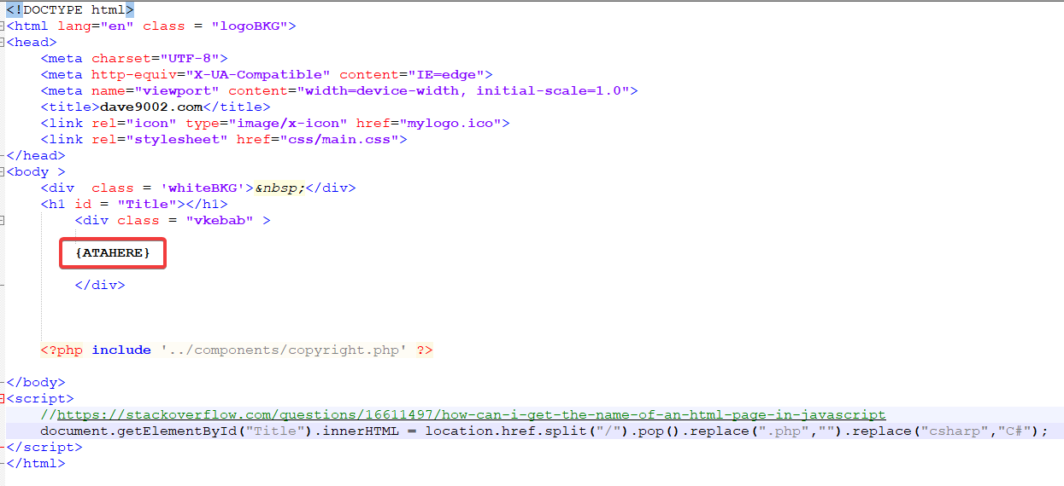
2.Create a .json file that starts with “ATA”

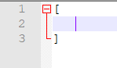
3. Edit the .json file and make an empty array.

4. Create the first JSON object to include an “output” field to indicate the name of the output file, a “maintemplate” to indicate the path of the template file from step 1, and a “mainrepeat” field to put the main template for every repeated element. For the element that changes with each iteration put it between curly braces {LIKETHIS}
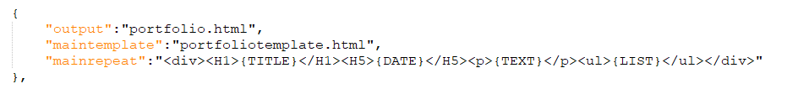
5. Add subsequent JSON objects with field names identical to what was put in curly braces.
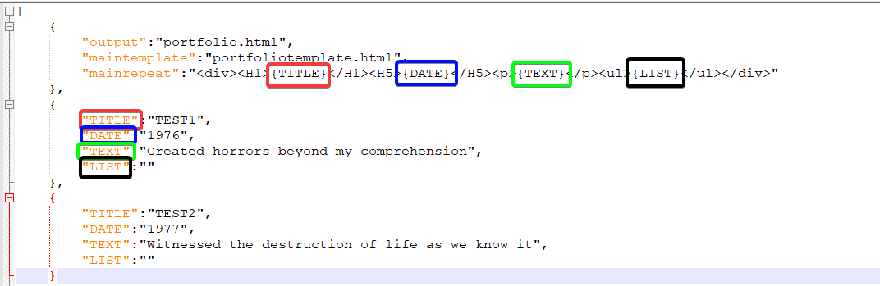
- To create a repeating element within a repeating element make the field value an array. The first element is the template, subsequent elements should be JSON objects like from step 5.
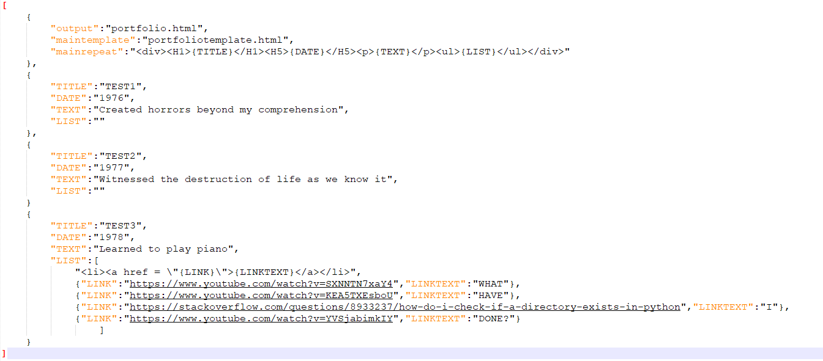
- Ensure the JSON and template file are in the same directory as AutoTemplateApply.py.
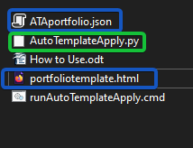
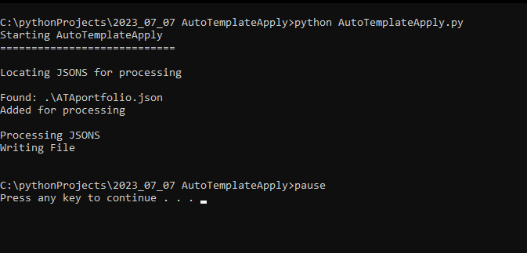
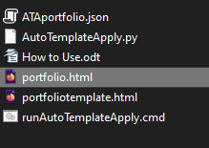
8. Run AutoTemplateApply.py. If it is successful you should see no error message and a new file.

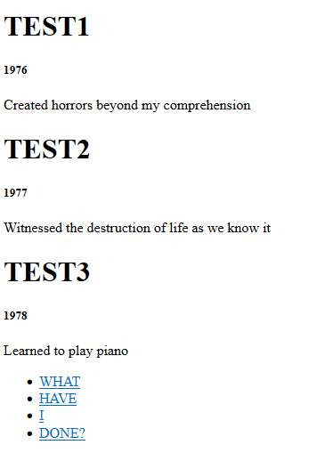
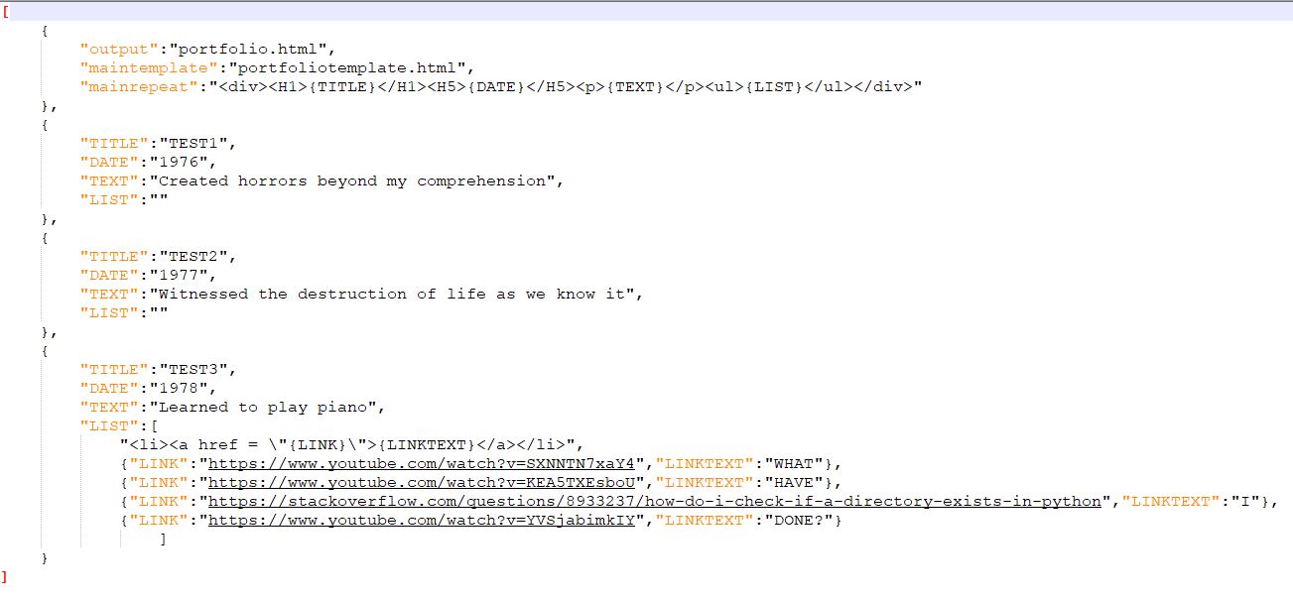
Output From Example:

